

History Form for Patient with
Temporomandibular Disorder

Date
Name Birth date
What problems do you have with your jaw joints, jaw muscles and/or teeth?
When did these problems start?
What do you think caused these problems?

SYMPTOMS Please mark each symptom that applies.
Jaw Joint Problems Left Right
Joint clicking or popping Yes No Yes No Comments
Grating noises Yes No Yes No Comments
Jaw locks open Yes No Yes No Comments
Jaw locks closed Yes No Yes No Comments
Limited jaw opening Yes No Yes No Comments
Jaw does not open smoothly Yes No Yes No Comments
Soreness of jaw joints Yes No Yes No Comments
Soreness of face muscles Yes No Yes No Comments

Teeth Problems
Teeth grinding Yes No Yes No Comments
Teeth clenching Yes No Yes No Comments
Soreness of one or more teeth Yes No Yes No Comments
Looseness of one or more teeth Yes No Yes No Comments

Head and Facial Pain Left Right (least) Degree of Pain (most)
Migraine type headache Yes No Yes No 0 1 2 3 4 5 6 7 8 9 10
Cluster headaches Yes No Yes No 0 1 2 3 4 5 6 7 8 9 10
Sinus headaches Yes No Yes No 0 1 2 3 4 5 6 7 8 9 10
Headaches in back of head Yes No Yes No 0 1 2 3 4 5 6 7 8 9 10
Hair and/or scalp painful to touch Yes No Yes No 0 1 2 3 4 5 6 7 8 9 10

Ear or Balance Problems
Pain in ear Yes No Comments
Ringing or buzzing Yes No Comments
Clogged or stuffy ears Yes No Comments
Diminished hearing Yes No Comments
Dizziness or vertigo Yes No Comments
Poor sense of balance Yes No Comments
Throat Problems
Swallowing difficulty Yes No Comments
Throat tightness Yes No Comments
Throat soreness Yes No Comments
Laryngitis Yes No Comments
Voice fluctuations Yes No Comments
Throat congestion Yes No Comments
Frequent cough Yes No Comments
Frequent throat clearing Yes No Comments
Excessive salivation Yes No Comments
Tongue pain Yes No Comments
Pain in roof of mouth Yes No Comments

Neck and/or Shoulder Pain
Neck/shoulder/back pain Yes No Comments
Neck/shoulder/back reduced mobility Yes No Comments
Frequent neck muscle fatigue Yes No Comments
Arm or finger tingling, numbness, pain Yes No Comments

Eye Problems
Pain around or behind eyes Yes No Comments
Bloodshot eyes Yes No Comments
Blurred vision Yes No Comments
Pressure behind eyes Yes No Comments
Light sensitivity Yes No Comments
Watering of eyes Yes No Comments
Drooping of eyelids Yes No Comments

On the figures below, mark an X where you have pain. Circle the X where the pain is most severe.

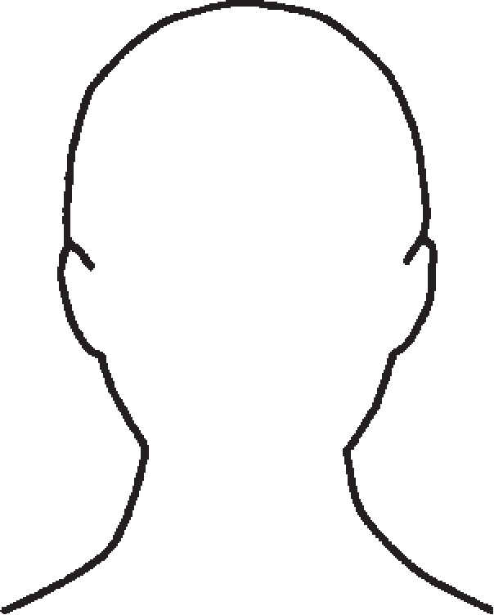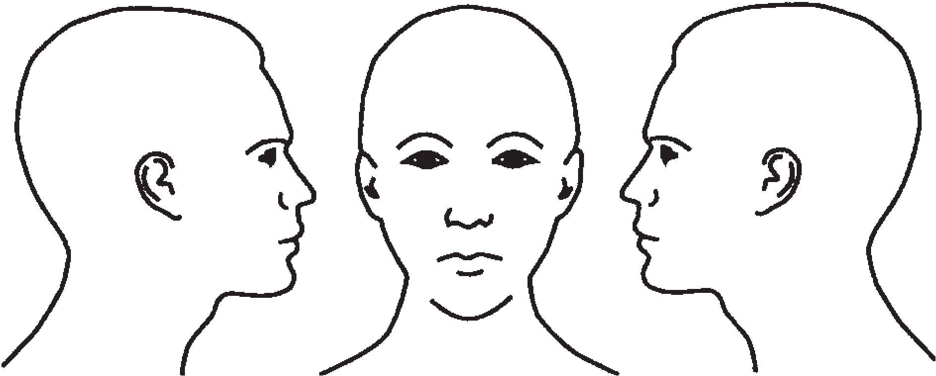

PATIENT HEALTH INFORMATION

Do you have any recent or childhood history of trauma to the head or face (such as falls, auto accident, blows to the head or face, sports injury)? If yes, please describe:

Do you have a frequent activity that causes you to hold your head or neck in an imbalanced position (such as playing instrument, keyboarding, holding phone, etc)? If yes, please describe:

Have you been treated for a TMD problem before? If so, when? By whom?

Was the problem the same or different than your current problem?

What treatment did you have?

Do you think the treatment was successful?

What would you like your treatment here to achieve?

UPDATES

Updates
Patient Signature ___________________________________________________________________ Date____________________________
Dental Staff Signature _______________________________________________________________ Date____________________________

Updates
Patient Signature ___________________________________________________________________ Date____________________________
Dental Staff Signature _______________________________________________________________ Date____________________________

Updates
Patient Signature ___________________________________________________________________ Date____________________________
Dental Staff Signature _______________________________________________________________ Date____________________________

